H.T No
Regulations:
A15

Sreenidhi Institute of Science and Technology
(An Autonomous Institution)
Code No: 5B518 Date: 14-July-2023 (FN)

B.Tech III-Year I- Semester External Examination, July - 2023 (Supplementary)
Design of Machine Members-I (ME)

Time: 3 Hours Max.Marks:75 Note: a) No additional answer sheets will be provided.
b) All sub-parts of a question must be answered at one place only, otherwise it will not be valued.
c) Missing data can be assumed suitably.

Bloom's Cognitive Levels of Learning (BCLL)
Remember | L1 | Apply | L3 | Evaluate | L5
Understand | L2 | Analyze | L4 | Create | L6

Part - A Max.Marks:25

Answer all QUESTIONS.
 |  | BCLL | CO(s) | Marks
1 | Define factor of safety and write its importance. | L1 | CO1 | [2M]
2 | Define notch sensitivity. | L1 | CO2 | [2M]
3 | List any four differences between cotter joint and knuckle joint. | L1 | CO3 | [2M]
4 | Define spring index. Write its importance. | L1 | CO4 | [2M]
5 | Define the self-locking in power screws. | L1 | CO5 | [2M]
6 | Write the assumptions made in the design of welded joint. | L1 | CO6 | [3M]
7 | Draw stress-time diagram for fluctuating stress and repeated stress. | L2 | CO2 | [3M]
8 | List any four applications of leaf spring. | L1 | CO4 | [3M]
9 | Explain the concept ofoverhauling of the screw. | L2 | CO5 | [3M]
10 | Discuss the concept of stiffness in bending. | L2 | CO1 | [3M]

Part – B Max.Marks:50
ANSWER ANY FIVE QUESTIONS. EACH QUESTION CARRIES 10 MARKS.

 |  |  | BCLL | CO(s) | Marks
11. | a) | Discuss the factors to be considered for the selection of materials for the design of machine elements. | L2 | CO1 | [5M]
 | b) | The stresses induced at a critical point in a machine component made of steel 45C8 (S_{yt} = 380 N/mm²) are as follows: σ_{x} = 100 N/mm²; σ_{x} = 40 N/mm²; τ_{xy} = 80 N/mm².Calculate the factor of safety by  (i) maximum normal stress theory  (ii) maximum shear stress theory (iii) maximum distortion energy theory | L3 | CO1 | [5M]
12. | a) | Describe the different types of cyclic stress. | L2 | CO2 | [5M]
 | b) | A cantilever beam made of cold drawn steel 20C8 (σut = 540 N/mm²) is subjected to a completely reversed load of 1000 N as shown in Figure. The notch sensitivity factor q at the fillet can be taken as 0.85 and the expected reliability is 90%. Determine the diameter of the bar for a life of 1000 cycles.  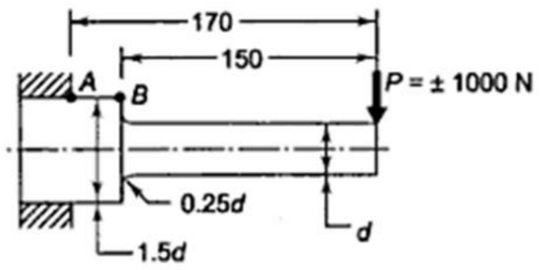 | L3 | CO2 | [5M]
13. | a) | It is required to design square key for fixing a pulley on the shaft, which is 25 mm in diameter. The pulley transmits 15 kW power at 720 rpm to the shaft. The key is made up of steel 50C4 (S_{yt} = 460 N/mm²) and the factor of safety is 3. Determine the dimensions of the key. | L3 | CO3 | [5M]
 | b) | Describe the design procedure of flange coupling. | L4 | CO3 | [5M]
14. | a) | A helical compression spring of a cam-mechanism is subjected to an initial preload of 50N. The maximum operating force during the load cycle is 150N. the wire diameter is 3mm, while the mean coil diameter is 18mm. the spring is made up of oil-hardened and tempered valve spring wire of grade-VW (S_{ut}=1430 N/mm²). Determine the factor of safety used in the design on the basis of fluctuating stresses. | L4 | CO4 | [5M]
 | b) | Wahl’s factor is to be considered in the design of helical compression or tension springs-Justify. | L2 | CO4 | [5M]
15. | a) | A bracket is bolted to a column by 6 bolts of equal size as shown in Figure. It carries a load of 50 kN at a distance of 150 mm from the centre of column. If the maximum stress in the bolts is to be limited to 150 MPa, determine the diameter of bolt.  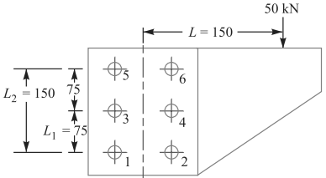  All dimensions are in mm | L4 | CO5 | [5M]
 | b) | Explain the strength of the riveted joint. | L2 | CO5 | [5M]
16. | a) | A bracket carrying a load of 15 kN is to be welded as shown in Figure. Find the size of weld required if the allowable shear stress is not to exceed 80 MPa.  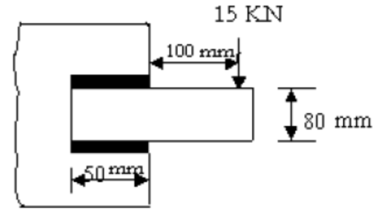 | L3 | CO6 | [5M]
 | b) | Classify the welded joints. | L2 | CO6 | [5M]
17. | a) | Explain thedesign of shaft based on the strength. | L2 | CO1 | [4M]
 | b) | Explain Goodman’s method to calculate the safe values of fluctuating stress. | L2 | CO2 | [3M]
 | c) | List any two applications and advantages of cotter joint. | L1 | CO3 | [3M]
18. | a) | Define the solid length and spring constant. | L2 | CO4 | [4M]
 | b) | Explain the bolts of uniform strength giving examples of practical applications of such bolts. | L2 | CO5 | [3M]
 | c) | Write the expression for the tensile strength of the joint for double fillet weld. | L3 | CO6 | [3M]

-- 00 -- 00 –

